Simulation of V2X communication under latency, vehicle speed, packet delivery ratio, throughput, and interference
Mathlab Code:
clc;
clear;
close all;

% Vehicle speed (km/h)
V = 10:10:120;

% Constant
K = 1000;

% Latency (ms)
Latency = K ./ V;

% Display values
disp('Vehicle Speed (km/h) Latency (ms)');
disp([V' Latency']);

% Plot
figure;
plot(V, Latency, '-o', 'LineWidth', 2);

grid on;
xlabel('Vehicle Speed (km/h)');
ylabel('Latency (ms)');
title('V2X Communication: Vehicle Speed vs Latency');
Output:
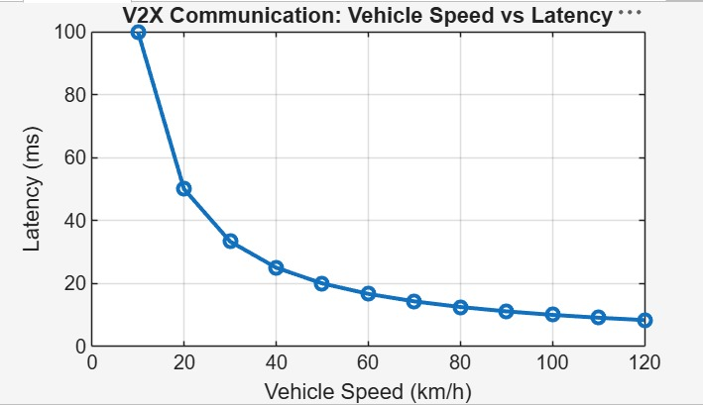

Mathlab Code 2
clc;
clear;
close all;

%% V2X Communication Simulation

% Simulation Parameters
numVehicles = 100; % Number of vehicles
roadLength = 1000; % meters
simulationTime = 100; % seconds

vehicleSpeed = 20 + 100*rand(numVehicles,1); % km/h (20-120)

packetSize = 1200; % Bytes
packetsSent = 500;

interferenceLevel = linspace(0,1,numVehicles);

%% Latency Calculation

latency = zeros(numVehicles,1);

for i=1:numVehicles
latency(i)=5 + 0.08*vehicleSpeed(i) + 12*interferenceLevel(i);
end

%% Packet Delivery Ratio

PDR = zeros(numVehicles,1);

for i=1:numVehicles

packetLossProbability = 0.05 + 0.35*interferenceLevel(i);

packetsReceived = packetsSent*(1-packetLossProbability);

PDR(i)=packetsReceived/packetsSent;

end

%% Throughput Calculation

throughput = (PDR*packetSize*8)./(latency/1000);

throughput = throughput/1e6; % Mbps

%% Display Average Results

fprintf('\n===== V2X Simulation Results =====\n');

fprintf('Average Vehicle Speed : %.2f km/h\n',mean(vehicleSpeed));

fprintf('Average Latency : %.2f ms\n',mean(latency));

fprintf('Average PDR : %.2f %%\n',mean(PDR)*100);

fprintf('Average Throughput : %.2f Mbps\n',mean(throughput));

fprintf('Average Interference : %.2f\n',mean(interferenceLevel));

%% Plot 1

figure;

scatter(vehicleSpeed,latency,50,'filled');

grid on;

xlabel('Vehicle Speed (km/h)');

ylabel('Latency (ms)');

title('Vehicle Speed vs Latency');

%% Plot 2

figure;

plot(interferenceLevel,PDR*100,'LineWidth',2);

grid on;

xlabel('Interference');

ylabel('Packet Delivery Ratio (%)');

title('Interference vs PDR');

%% Plot 3

figure;

plot(vehicleSpeed,throughput,'r','LineWidth',2);

grid on;

xlabel('Vehicle Speed (km/h)');

ylabel('Throughput (Mbps)');

title('Vehicle Speed vs Throughput');

%% Plot 4

figure;

bar([mean(latency),mean(PDR)*100,mean(throughput)]);

set(gca,'XTickLabel',{'Latency','PDR','Throughput'});

title('Average Network Performance');

grid on;

Outputs:
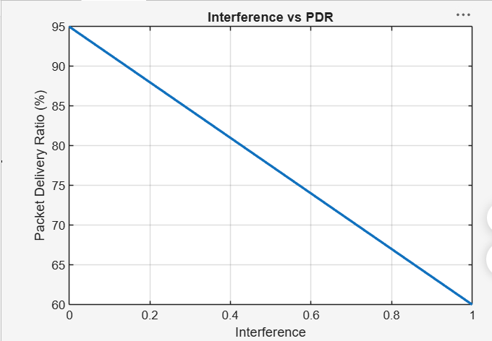
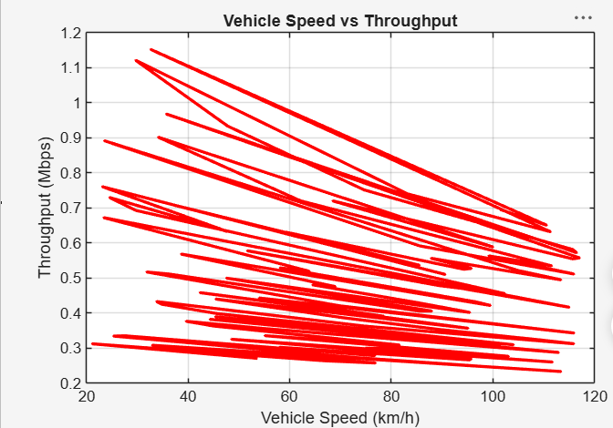
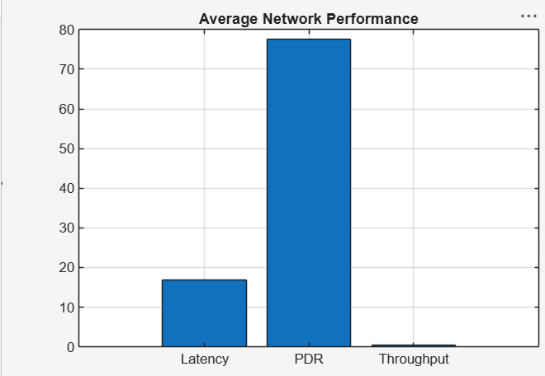
Simulation of LTE resource block allocation under different user numbers, scheduling methods, bandwidths, traffic load, and interference levels
clc;
clear;
close all;

%% LTE Resource Block Allocation Simulation

% Simulation Parameters
numUsers = 10:10:100; % Users
bandwidth = 20; % MHz
RB_total = 100; % LTE Resource Blocks (20 MHz)
trafficLoad = 0.2:0.2:1.0; % Traffic Load
interference = 0:0.2:1; % Interference Level

scheduler = {'Round Robin','Best CQI','Proportional Fair'};

%% Simulation

Throughput = zeros(length(numUsers),3);
Fairness = zeros(length(numUsers),3);
Utilization = zeros(length(numUsers),3);

for s = 1:3

for i = 1:length(numUsers)

users = numUsers(i);

% Average Channel Quality Indicator (CQI)
CQI = randi([1 15],users,1);

switch s

case 1 % Round Robin
RB_alloc = floor(RB_total/users)*ones(users,1);

case 2 % Best CQI
weight = CQI/sum(CQI);
RB_alloc = round(weight*RB_total);

case 3 % Proportional Fair
avgRate = rand(users,1)+0.5;
metric = CQI./avgRate;
weight = metric/sum(metric);
RB_alloc = round(weight*RB_total);

end

RB_alloc(RB_alloc<0)=0;

Utilization(i,s)=sum(RB_alloc)/RB_total*100;

rate = RB_alloc.*CQI*(1-0.3*mean(interference));

Throughput(i,s)=sum(rate);

Fairness(i,s)=(sum(RB_alloc)^2)/(users*sum(RB_alloc.^2));

end

end

%% Display Sample Results

fprintf('===== LTE Resource Block Allocation =====\n\n');

for s=1:3

fprintf('%s Scheduler\n',scheduler{s});

fprintf('Average Throughput : %.2f Mbps\n',mean(Throughput(:,s)));

fprintf('Average Fairness : %.3f\n',mean(Fairness(:,s)));

fprintf('Average Utilization: %.2f %%\n\n',mean(Utilization(:,s)));

end

%% Graph 1 - Throughput

figure;

plot(numUsers,Throughput(:,1),'-o','LineWidth',2);
hold on;
plot(numUsers,Throughput(:,2),'-s','LineWidth',2);
plot(numUsers,Throughput(:,3),'-^','LineWidth',2);

grid on;

xlabel('Number of Users');

ylabel('System Throughput');

title('Throughput vs Number of Users');

legend(scheduler,'Location','best');

%% Graph 2 - Fairness

figure;

plot(numUsers,Fairness(:,1),'-o','LineWidth',2);
hold on;
plot(numUsers,Fairness(:,2),'-s','LineWidth',2);
plot(numUsers,Fairness(:,3),'-^','LineWidth',2);

grid on;

xlabel('Number of Users');

ylabel('Jain Fairness Index');

title('Fairness Comparison');

legend(scheduler,'Location','best');

%% Graph 3 - Resource Utilization

figure;

bar(Utilization);

xlabel('User Index');

ylabel('Resource Utilization (%)');

title('Resource Block Utilization');

legend(scheduler);

%% Graph 4 - Traffic Load

figure;

thr = zeros(length(trafficLoad),1);

for i=1:length(trafficLoad)

thr(i)=RB_total*15*trafficLoad(i)*(1-mean(interference));

end

plot(trafficLoad*100,thr,'r-*','LineWidth',2);

grid on;

xlabel('Traffic Load (%)');

ylabel('Estimated Throughput');

title('Traffic Load vs Throughput');

%% Graph 5 - Interference Effect

figure;

pdr = (1-interference)*100;

plot(interference,pdr,'k-o','LineWidth',2);

grid on;

xlabel('Interference Level');

ylabel('Packet Success Rate (%)');

title('Interference Impact on LTE Performance');
Output:
